- \Operation\Tube filling\Shut-off
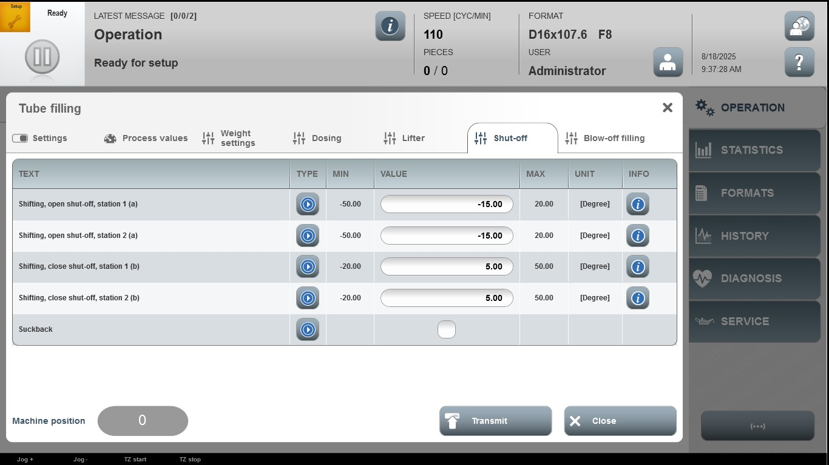

Acceptance criterion | Limits | Pass / Fail: Dev-No. | Date | Initials
Screen matches screenshot | N / A
Shifting, open shut-off, station 1 (a) | -50.00…20.00
Shifting, open shut-off, station 2 (a) | -50.00…20.00
Shifting, close shut-off, station 1 (b) | -20.00…50.00
Shifting, close shut-off, station 2 (b) | -20.00…50.00

